Singleton Pattern
# Source: AI Source: Provided by: [Data Path: Persons Table -> ID Column: 1, Name_En Column: Motasem Essam] -> From: [ChatGPT] on [1/23/2026]
The Singleton Pattern ensures that a class has only one instance and provides a global point of access to it.
👉 Think of it like a company CEO: only one exists, but everyone can access their decisions.

🔑 Key Points
# Source: AI Source: Provided by: [Data Path: Persons Table -> ID Column: 1, Name_En Column: Motasem Essam] -> From: [ChatGPT] on [1/23/2026]
• Only one instance of the class exists
• Provides global access
• Commonly used for managers, loggers, configuration objects, or caches

❌ Bad Example
# Source: AI Source: Provided by: [Data Path: Persons Table -> ID Column: 1, Name_En Column: Motasem Essam] -> From: [ChatGPT] on [1/23/2026]
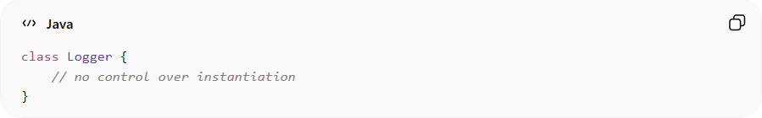
class Logger {
// no control over instantiation
}
Problems:
• Multiple instances can be created
• Global state can lead to inconsistent behavior

✅ Good Example
# Source: AI Source: Provided by: [Data Path: Persons Table -> ID Column: 1, Name_En Column: Motasem Essam] -> From: [ChatGPT] on [1/23/2026]
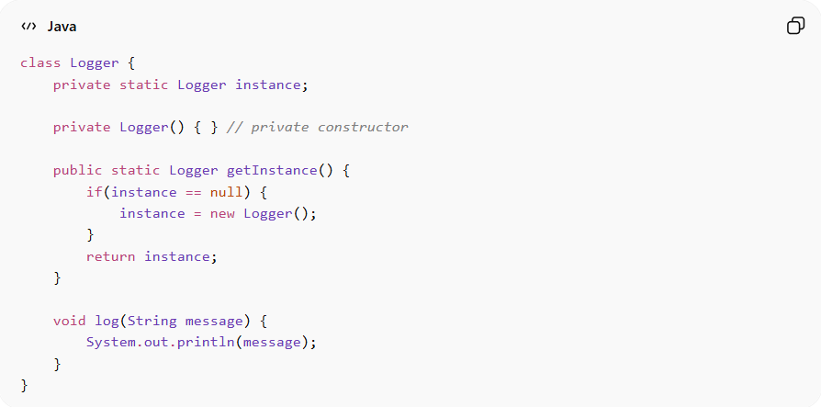
class Logger {
private static Logger instance;

private Logger() { } // private constructor

public static Logger getInstance() {
if(instance == null) {
instance = new Logger();
}
return instance;
}

void log(String message) {
System.out.println(message);
}
}
Benefits:
• Controlled access to a single instance
• Saves memory and resources
• Ensures consistent behavior across system

⚡ Advantages
# Source: AI Source: Provided by: [Data Path: Persons Table -> ID Column: 1, Name_En Column: Motasem Essam] -> From: [ChatGPT] on [1/23/2026]
• Guarantees single instance of a class
• Easy to implement in simple scenarios
• Provides global access point

⚠️ Disadvantages
# Source: AI Source: Provided by: [Data Path: Persons Table -> ID Column: 1, Name_En Column: Motasem Essam] -> From: [ChatGPT] on [1/23/2026]
• Can introduce global state, making testing harder
• Hard to subclass or extend
• May lead to tight coupling if overused

🛠️ Use Cases
# Source: AI Source: Provided by: [Data Path: Persons Table -> ID Column: 1, Name_En Column: Motasem Essam] -> From: [ChatGPT] on [1/23/2026]
• Logging systems – centralized logging
• Configuration managers – single source of truth for settings
• Caches – single shared cache
• Thread pools or database connections – control instance count

